Written in 20110506

Some ideas about data base feature

1. First step
When writing on disk: Save only the data not the whole stuf.
To do that write in a file these information: page, line, row, pid...
The (re)Load data or do nothin' choices are open.

a. The main idea
to have a server that is watching data base.

b. At the beginning
If there is no server already launched then start it if not do not launch and start a query.

2. Second step
When another wants to write at the same time no server as to be launched just it has to give the query.

ArgoUML or Umbrello are both Open Source. ArgoUML will be used to do use case diagram.

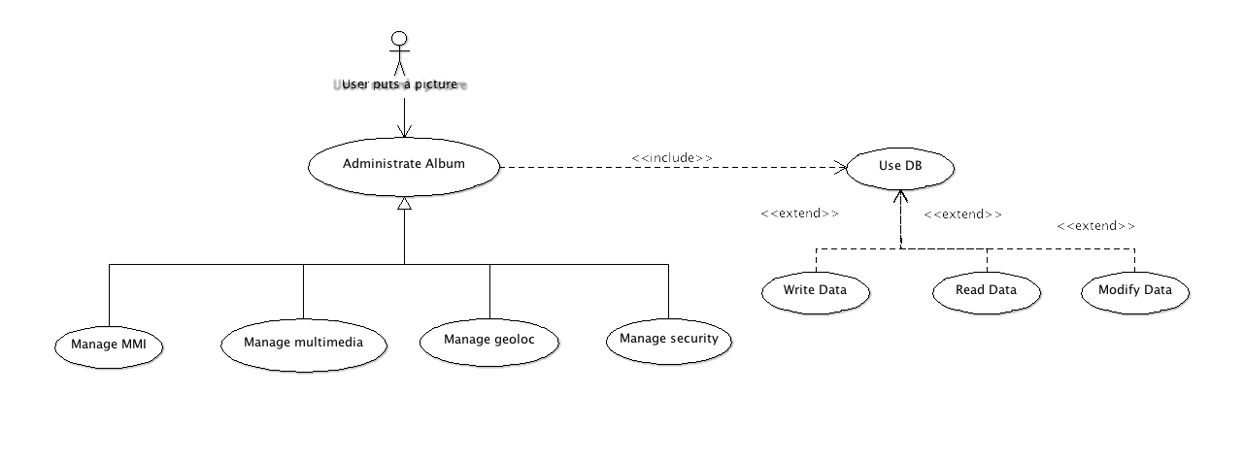
Case diagram features of the album

